****Year 7 Science Task 5

**Investigating Levers: Validation test**

Student name: ____________________________________

Test materials

* Pen or pencil
* Calculator
* Task 8 Levers Investigation worksheet with **no additional notes or fact sheets**

**/36**

**Organisation:** worksheet brought to class on test date completed and handed in with test (2 marks)

**Investigation questions**

1. Write the **definition** of the following terms: (2 marks)
2. Independent variable: _______________________________________________________________

_________________________________________________________________________________

1. Dependent variable: _______________________________________________________________

_________________________________________________________________________________

1. Draw a bar graph of your results below. (5 marks)
2. Describe the results of your investigation (3 marks)

_____________________________________________________________________________________________________________________________________________________________________________________________________________________________________________________________________________________________________________________________________________________________________________________________________________________

1. Look at your results to answer the following questions: (3 marks)
2. What was the furthest distance thrown without the dog ball thrower? ____________
3. What was the shortest distance thrown with the dog ball thrower? ____________
4. What is the difference in the average distance thrown with the dog ball thrower and without the dog ball thrower? ____________
5. Using your results from your team average for both throwing methods, which method made the tennis ball travel further? (3 marks)

____________________________________________________________________________________________________________________________________________________________________________________________________________________________________________________________________________________________________________________________________

1. Using your knowledge of levers, explain why the dog ball thrower often throws further than just the arm. Your answer should be one paragraph. (4 marks)

_______________________________________________________________________________________________________________________________________________________________________________________________________________________________________________________________________________________________________________________________________________________________________________________________________________________________________________________________________________________________________________________________________________________________________________________

1. Describe one thing you could do to make the experiment results more reliable if you were to do this experiment again (2 marks)

___________________________________________________________________________________________________________________________________________________________________________________________________________________________________________________

**Levers**

1. Compare and contrast (find the similarities and differences) first class and second class levers. Provide examples of each in your answer (4 marks)

______________________________________________________________________________________________________________________________________________________________________________________________________________________________________________________________________________________________________________________________________________________________________________________________________________________________________________________________________________________________________

1. What is the pivot point on a lever called? _____________________ (1 mark)
2. Explain using words and a diagram why the dog ball thrower is a third class lever. (3 marks)

____________________________________________________________________________________________________________________________________________________________________________________________________________________________________________________________________________________________________________________________________

1. Annotate the following image to show the effort, pivot, load, and motion (2 marks)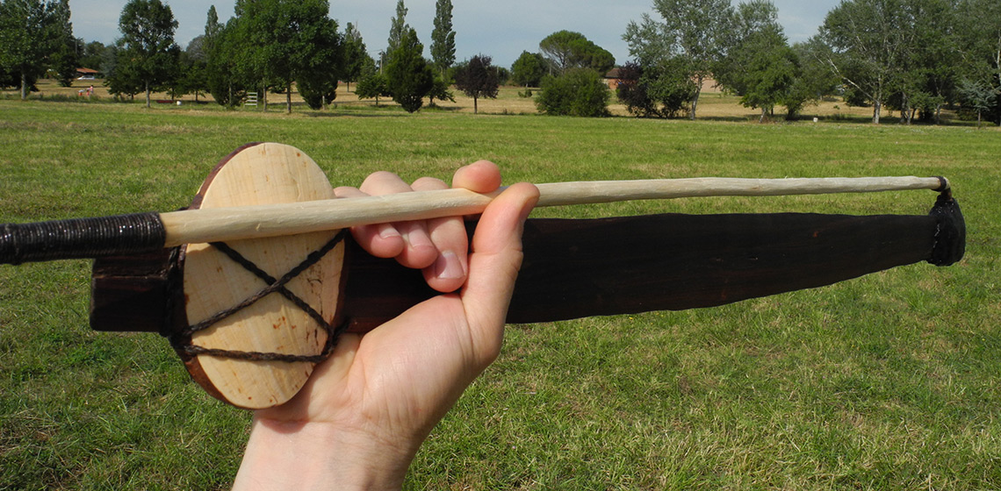
2. What are **two** mechanical advantages the miro gives the thrower? (2 marks)

____________________________________________________________________________________________________________________________________________________________________________________________________________________________________________________________________________________________________________________________________